Extreme Weather and Climate Change

Devastating deluges, record floods and deadly heat waves have raised the question of whether there’s a connection between these events and global warming. The bottom line answer is yes: Heat waves are longer and hotter than they used to be and some regions are suffering from catastrophic drought. Heavy rains are more frequent and can be more intense and rainfall records have been smashed. These events fit a pattern that climate scientists have long expected to appear as the result of increased greenhouse gases in our atmosphere. That doesn’t mean global warming is the only culprit: extreme weather was happening before global warming began. But there’s general scientific agreement that global warming has contributed to a trend toward more intense extremes of heat and precipitation around the world, is partly to blame for specific extreme weather events over the last decade and will continue to influence both in the future.
WHAT WE KNOW

- On average, the US is 2 degrees F warmer than it was 40 years ago.

- This warmer world is increasing the odds of extreme precipitation,^{(21,22)} in part because a warmer atmosphere can hold more moisture, and release more of it during rainstorms and snowstorms.

- Heavy precipitation, both rain and snow, is happening more often than it used to.^{(10,4)}

- Heat-related extreme events are on the rise around the globe. Manmade climate change significantly increased the odds of some specific events, including the killer European heat wave of 2003⁽⁶⁾ and the Russian heat wave of 2010.⁽¹²⁾

- Even small increases in average temperatures raise the risk of heat waves ^{(6a, 6b)}, droughts⁽⁷⁾ and wildfires.⁽⁸⁾

- Twice as many record highs have been set in the past decade as record lows, in the US. ⁽⁹⁾

- By 2050, record highs could outpace record lows by 20 to one in the U.S. By the end of the century, the ratio could jump to 100 to one if greenhouse gas emissions continue unabated.⁽⁹⁾

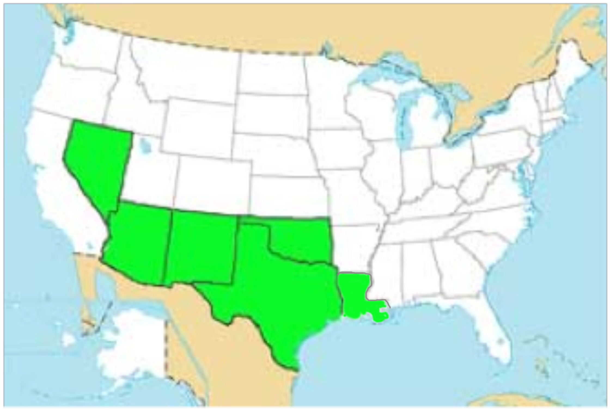

THE SOUTHWEST

Extreme Heat and Drought of 2011

Texans love to brag about how big their state is along with everything in it. Not so much this year, though, as record-breaking heat, drought and wildfires relentlessly pummeled Texans. The heat struck nearby Oklahoma, Louisiana and New Mexico too, pushing all of the states’ resources, along with their residents, to the brink of disaster—and in many cases, right over the edge.
Scientists know that climate change is making heat extremes like those experienced in the Southwest this year more intense and more frequent.

What happened in 2011:

- Texas, Oklahoma, New Mexico and Louisiana had their hottest summers on record this year.
HEAT RECORDS BROKEN
in 2011
In August alone, Texas broke >4,000
high temperature records

Their Hottest Summer On Record
Texas
Oklahoma
New Mexico
Arizona
Louisiana
Colorado

>100 Days over 100° F
Wichita Falls, Texas

86 Days over 100° F
All of Oklahoma

90 Days over 100° F
Austin, Texas
Hottest Summer in US History
Texas

- Texas had the warmest summer of any state in the U.S. going back to when modern records began in 1895 and set more than 4,000 hot temperature records in August alone. Oklahoma came in second and both states beat records set during the Dust Bowl era in the 1930s.

- Nationally, the ratio of record highs to record lows this summer was 4.35 to 1. But in Texas, the ratio was 80 to 1.

- In Texas, the average statewide temperature for the summer (night and day) was a whopping 86. 8°F.
- Every state in the Lower-48 except North Dakota and Vermont had at least one day with a temperature topping 100°F. Many cities broke all-time heat records. Austin, Texas set new records for the most 100° days, the hottest month, the hottest summer and the
hottest day in history (112°F, tied with Sep, 5, 2000).
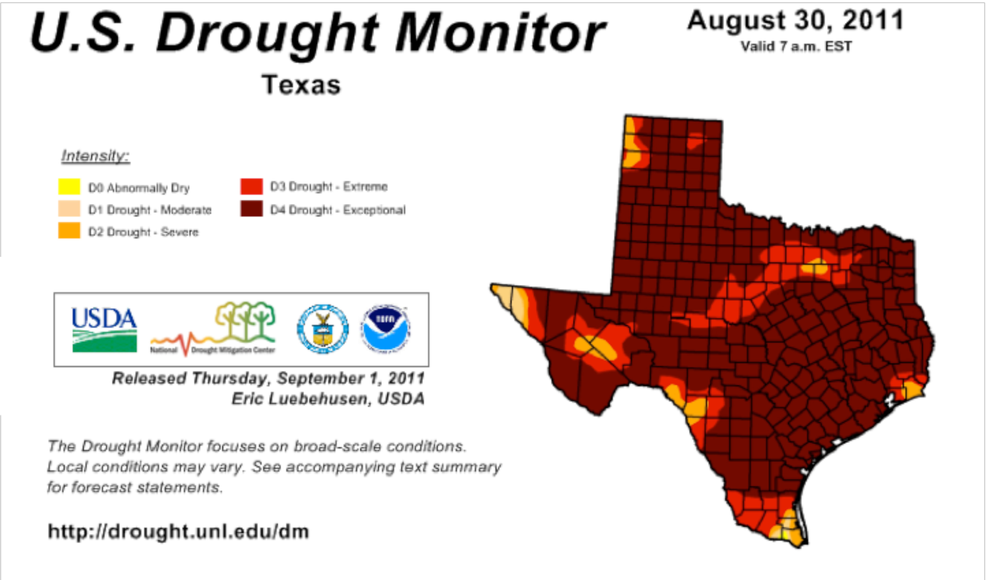
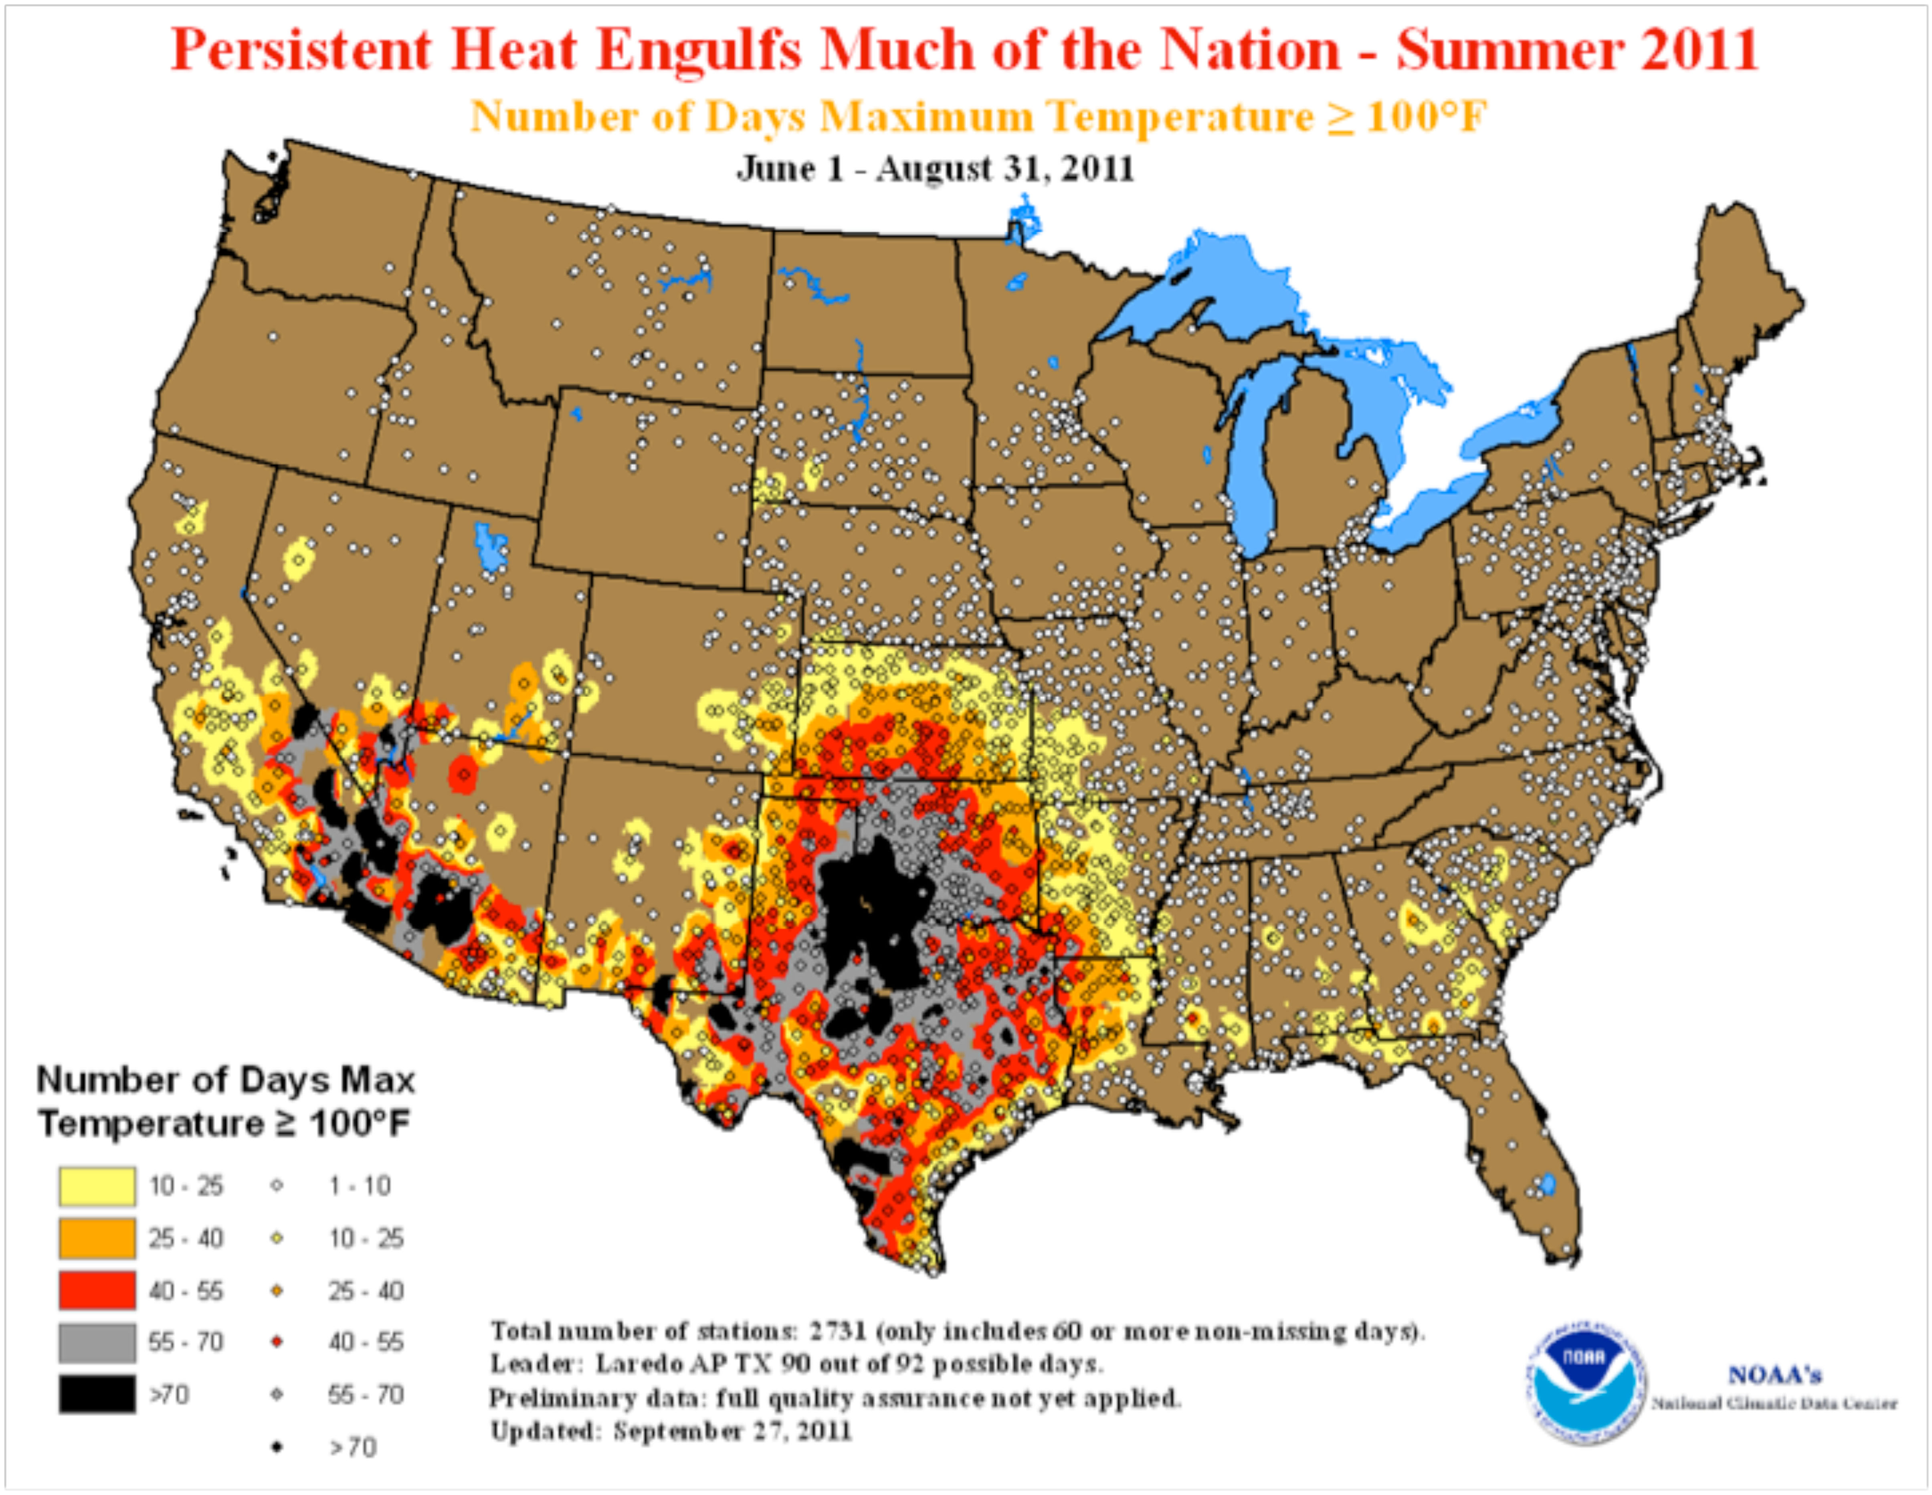
Degree of drought intensity in Texas on August 30, 2011
credit: http://www.ncdc.noaa.gov/sotc/hazards/2011/8

Number of days the maximum temperature exceeded 100 °F. credit: http://www.ncdc.noaa.gov/sotc/national/2011/8
Texas Drought and Wildfires
DROUGHT &WILDFIRE RECORDS BROKEN in 2011

Worst One-year Drought On Record
Texas
(Sept 2010-August 2011)

Number of Acres Burned in:
Texas: 3.5 million acres
New Mexico: 156,000 acres
(Las Conchas Fire)
Arizona: 538,000 acres in the
(Wallow Fire)

- Climate change is creating drier conditions in the American Southwest,⁽¹⁵⁾ and has been linked to increases in forest acres burned in some regions of the West.^{(8,16)}
- These drier conditions are aggravated by natural climate cycles, such as La Nina, a significant factor in this year’s drought, which tend to favor drought in the Southwest. Global warming could boost the intensity and impact of these La Nina-related droughts.^{(18,19,20)}

- For every additional degree of global warming, the number of acres burned in Southwest wildfires is projected to increase dramatically — at the same time as rain and snowfall decrease.⁽¹⁷⁾

- At the end of September, 97 percent of Texas was in one of the top two most severe categories of drought, according to the U.S. Drought Monitor. That’s a new state record.

- Drought and extreme heat combined to create Texas’ worst wildfire season on record, with nearly four million acres burned so far.

- Texas broke a record for the driest 12-month period on record. The drought has cost Texas an estimated $5.2 billion in agricultural losses and at least $1 billion in other damage, making it the most costly drought in the state’s history.

- The drought is driving up the price of beef as ranchers are forced to sell their herds early. Lower cotton yields could force up cotton prices and peanut, corn and wheat crops have also been hit hard.
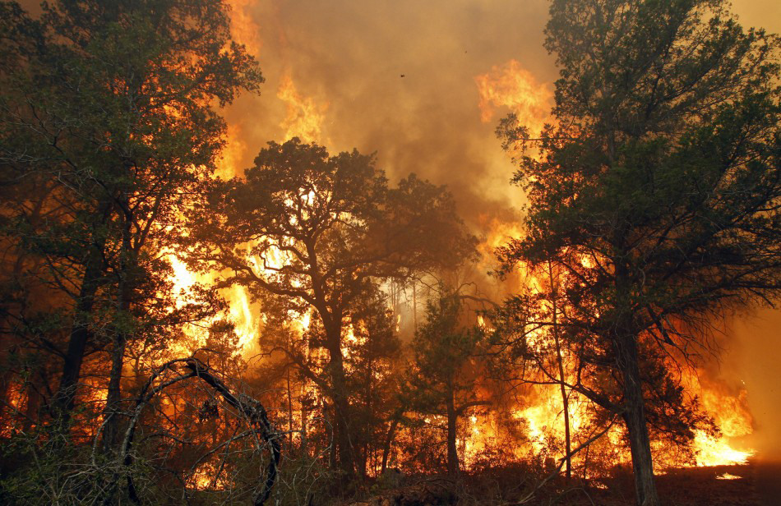
- The Bastrop fire, which ignited east of Austin on September 4, burned over 34,000 acres, killed two people and destroyed more than 1,600 homes, breaking the state record for the most homes lost in a single wildfire. It was also the most expensive wildfire in Texas history.
- New Mexico also suffered from unusually severe wildfires. At one point, the Las Conchas wildfire, which burned nearly 130,000 acres, threatened the Energy Department’s Los Alamos National Laboratory, the birthplace of the atomic bomb.
Bastrop State Park as a wildfire burns out of control
References

⁽¹⁾ Hegerl, G.C., F. W. Zwiers, P. Braconnot, N.P. Gillett, Y. Luo, J.A. Marengo Orsini, N. Nicholls, J.E. Penner and P.A. Stott, 2007: Understanding and Attributing Climate Change. In: Climate Change 2007: The Physical Science Basis. Contribution of Working Group I to the Fourth Assessment Report of the Intergovernmental Panel on Climate Change [Solomon, S., D. Qin, M. Manning, Z. Chen, M. Marquis, K.B. Averyt, M. Tignor and H.L. Miller (eds.)]. Cambridge University Press, Cambridge, United Kingdom and New York, NY, USA.

⁽²⁾Identification of human-induced changes in atmospheric moisture content
Author(s): Santer B. D.; Mears C.; Wentz F. J.; et al.
Source: PROCEEDINGS OF THE NATIONAL ACADEMY OF SCIENCES OF THE UNITED STATES OF AMERICA Volume: 104 Issue: 39 Pages: 15248-15253 DOI: 10.1073/pnas.0702872104 Published: SEP 25 2007

⁽³⁾ Trapp, R. J., N. S., Diffenbaugh, and A. Gluhovsky (2009), Transient response of severe thunderstorm forcing to elevated greenhouse gas concentrations, Geophys. Res. Lett., 36, L01703, doi:10.1029/2008GL036203.

⁽⁴⁾ Trenberth, K.E., P.D. Jones, P. Ambenje, R. Bojariu, D. Easterling, A. Klein Tank, D. Parker, F. Rahimzadeh, J.A. Renwick, M. Rusticucci, B. Soden and P. Zhai, 2007: Observations: Surface and Atmospheric Climate Change. In: Climate Change 2007: The Physical Science Basis. Contribution of Working Group I to the Fourth Assessment Report of the Intergovernmental Panel on Climate Change [Solomon, S., D. Qin, M. Manning, Z. Chen, M. Marquis, K.B. Averyt, M. Tignor and H.L. Miller (eds.)]. Cambridge University Press, Cambridge, United Kingdom and New York, NY, USA.

^{(5a)} Stott, P. A., Gillett, N. P., Hegerl, G. C., Karoly, D. J., Stone, D. A., Zhang, X. and Zwiers, F., 2010: Detection and attribution of climate change: a regional perspective. Wiley Interdisciplinary Reviews: Climate Change, 1: 192–211. doi: 10.1002/wcc.34;

^{(5b)} Meehl, G.A., T.F. Stocker, W.D. Collins, P. Friedlingstein, A.T. Gaye, J.M. Gregory, A. Kitoh, R. Knutti, J.M. Murphy, A. Noda, S.C.B. Raper, I.G. Watterson, A.J. Weaver and Z.-C. Zhao, 2007: Global Climate Projections. In: Climate Change 2007: The Physical Science Basis. Contribution of Working Group I to the Fourth Assessment Report of the Intergovernmental Panel on Climate Change [Solomon, S., D. Qin, M. Manning, Z. Chen, M. Marquis, K.B. Averyt, M. Tignor and H.L. Miller (eds.)]. Cambridge University Press, Cambridge, United Kingdom and New York, NY, USA.

^{(6a)} Christidis, N., P.A. Stott, and S. Brown, 2011: The role of human activity in the recent warming of extremely warm daytime temperatures. Journal of Climate doi:10.1175/2011JCLI4150.1

^{(6b)} Human contribution to the European heatwave of 2003 (vol 432, pg 610, 2004)
Author(s): Stott PA; Stone DA; Allen MR
Source: NATURE Volume: 436 Issue: 7054 Pages: 1200-1200 DOI: 10.1038/nature04099 Published: AUG 25 2005

⁽⁷⁾ Drought under global warming: a review
Author(s): Dai Aiguo
Source: WILEY INTERDISCIPLINARY REVIEWS-CLIMATE CHANGE Volume: 2 Issue: 1 Pages: 45-65 DOI: 10.1002/wcc.81 Published: JAN-FEB 2011

⁽⁸⁾ Detecting the effect of climate change on Canadian forest fires
Author(s): Gillett NP; Weaver AJ; Zwiers FW; et al.
Source: GEOPHYSICAL RESEARCH LETTERS Volume: 31 Issue: 18 Article Number: L18211 DOI: 10.1029/2004GL020044 Published: SEP 29 2004

⁽⁹⁾ Relative increase of record high maximum temperatures compared to record low minimum temperatures in the U. S.
Author(s): Meehl Gerald A.; Tebaldi Claudia; Walton Guy; et al.
Source: GEOPHYSICAL RESEARCH LETTERS Volume: 36 Article Number: L23701 DOI: 10.1029/2009GL040736 Published: DEC 1 2009

⁽¹⁰⁾ Global observed changes in daily climate extremes of temperature and precipitation
Author(s): Alexander LV; Zhang X; Peterson TC; et al.
Source: JOURNAL OF GEOPHYSICAL RESEARCH-ATMOSPHERES Volume: 111 Issue: D5 Article Number: D05109 DOI: 10.1029/2005JD006290 Published: MAR 15 2006
⁽¹¹⁾ Single-step attribution of increasing frequencies of very warm regional temperatures to human influence
Author(s): Stott Peter A.; Jones Gareth S.; Christidis Nikolaos; et al.
Source: ATMOSPHERIC SCIENCE LETTERS Volume: 12 Issue: 2 Pages: 220-227 DOI: 10.1002/asl.315 Published: APR-JUN 2011
⁽¹²⁾ Rahmstorf, S. and D. Coumou, 2011, Increase in extreme events in a warming world. Proceeding of the National Academy of Science, 108 (44) 17905-17909, doi 10.1073/pnas.1101766108.

⁽¹³⁾ Confalonieri, U., B. Menne, R. Akhtar, K.L. Ebi, M. Hauengue, R.S. Kovats, B. Revich and A. Woodward, 2007: Human health. Climate Change 2007: Impacts, Adaptation and Vulnerability. Contribution of Working Group II to the Fourth Assessment Report of the Intergovernmental Panel on Climate Change, M.L. Parry, O.F. Canziani, J.P. Palutikof, P.J. van der Linden and C.E. Hanson, Eds., Cambridge University Press, Cambridge, UK, 391-431.
⁽¹⁴⁾ Easterling, W.E., P.K. Aggarwal, P. Batima, K.M. Brander, L. Erda, S.M. Howden, A. Kirilenko, J. Morton, J.-F. Soussana, J. Schmidhuber and F.N. Tubiello, 2007: Food, fibre and forest products. Climate Change 2007: Impacts, Adaptation and Vulnerability. Contribution of Working Group II to the Fourth Assessment Report of the Intergovernmental Panel on Climate Change, M.L. Parry, O.F. Canziani, J.P. Palutikof, P.J. van der Linden and C.E. Hanson, Eds., Cambridge University Press, Cambridge, UK, 273-313.
⁽¹⁵⁾ Human-induced changes in the hydrology of the western United States
Author(s): Barnett Tim P.; Pierce David W.; Hidalgo Hugo G.; et al.
Source: SCIENCE Volume: 319 Issue: 5866 Pages: 1080-1083 DOI: 10.1126/science.1152538 Published: FEB 22 2008
Times Cited: 151 (from Web of Science)

⁽¹⁶⁾ Climate and wildfire area burned in western U. S. ecoprovinces, 1916-2003
Author(s): Littell Jeremy S.; McKenzie Donald; Peterson David L.; et al.
Source: ECOLOGICAL APPLICATIONS Volume: 19 Issue: 4 Pages: 1003-1021 DOI: 10.1890/07-1183.1 Published: JUL 2009
Times Cited: 44 (from Web of Science)

⁽¹⁷⁾ Solomon, S. et al. , 2011, Climate Stabilization Targets, NRC Report. The National Academies Press. Washington, DC, 286 pp.

⁽¹⁸⁾ Distinct causes for two principal US droughts of the 20th century
Author(s): Hoerling Martin; Quan Xiao-Wei; Eischeid Jon
Source: GEOPHYSICAL RESEARCH LETTERS Volume: 36 Article Number: L19708 DOI: 10.1029/2009GL039860 Published: OCT 8 2009

⁽¹⁹⁾ Dominant modes of moisture flux anomalies over North America
Author(s): Dominguez F; Kumar P
Source: JOURNAL OF HYDROMETEOROLOGY Volume: 6 Issue: 2 Pages: 194-209 DOI: 10.1175/JHM417.1 Published: APR 2005

⁽²⁰⁾The climate of the US Southwest
Author(s): Sheppard PR; Comrie AC; Packin GD; et al.
Source: CLIMATE RESEARCH Volume: 21 Issue: 3 Pages: 219-238 DOI: 10.3354/cr021219 Published: JUL 16 2002

⁽²¹⁾ Min S., X. Zhang, F. Zwiers, and G. Hegerl, 2011: Human contribution to more-intense precipitation extremes. Nature 2011 Volume: 470, Pages: 378–381. doi:10.1038/nature09763

⁽²²⁾ Anthropogenic greenhouse gas contribution to flood risk in England and Wales in autumn 2000
Author(s): Pall Pardeep; Aina Tolu; Stone Daithi A.; et al.
Source: NATURE Volume: 470 Issue: 7334 Pages: 382-385 DOI: 10.1038/nature09762 Published: FEB 17 2011

